Data Script

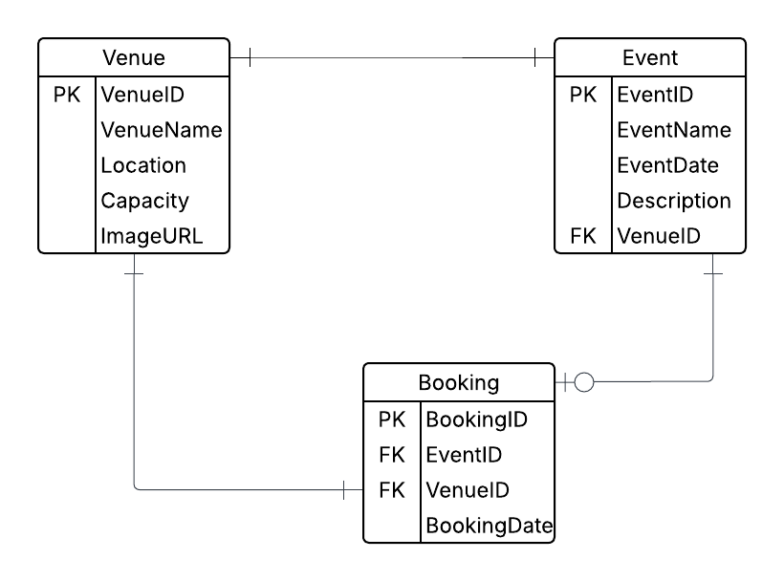

REATE TABLE [Venue] (

[VenueID] <type>,

[VenueName] <type>,

[Location] <type>,

[Capacity] <type>,

[ImageURL] <type>,

PRIMARY KEY ([VenueID])

);

CREATE TABLE [Event ] (

[EventID] <type>,

[EventName] <type>,

[EventDate] <type>,

[Description] <type>,

[VenueID] <type>,

PRIMARY KEY ([EventID])

);

CREATE TABLE [Booking] (

[BookingID ] <type>,

[EventID] <type>,

[VenueID] <type>,

[BookingDate] <type>,

PRIMARY KEY ([BookingID ])

);

Cloud Development PART 1 NUMBER D

Deploying your application on cloud versus on premises has its key differences. These differences include security, deployment speed and resource management, the following paragraphs will explain these differences and provide some examples.

Security

In the cloud deployment there are shared responsibilities, meaning cloud providers like Azure or AWS provide the customers with infrastructure security and the customer secure the application and the data An example of this can be found in Azure where you get your built in encryptions, firewalls and DDoS protection. This allows you have role based access with minimal setup.

On-premises you are required to be responsible for all aspects of security which may include the company’s physical servers, firewalls, the network and OS, plus the application. An example of this can be the company will have to set-up its own firewalls and backup its data manually.

Deployment speed

Cloud Deployment is very fast because of automation tools such as CI/CD pipelines and Azure DevOps. A clear example of this is you can deploy an application to Azure quickly using Visual Studio.

On-premises deployment can very slow and time consuming because of manual configurations and hardware provisions. An example of this can be found deploying an update might require the company’s system to be down for a few hours to be able to deploy the update.

Resource management

In a Cloud environment resource management is a bit easier as you can actively add and remove resources and the cloud provider you are using and automatically do this for you. An example of this can be seen if an application is experiencing high traffic, Azure App Services can automatically scale up without any employee intervention.

On- Premises resource management can a bit difficult to deal with as all the company’s infrastructure is located and managed at the company’s physical location. The IT department will be fully responsible for monitoring, configuring, and maintaining the infrastructure. This can be time-consuming because if the company is looking to scale-up, they will be required to do it manually. This means the company will have to buy hardware, configure it and install it. An example of this can be seen if the company is needs to install a new database server which is something that might take days or weeks to configure and install.

2. **IaaS (Infrastructure as a Service)** provide as pay as you go virtual machines over the internet. You are able to control and manage the machine’s OS, updates and patches, and lastly the runtime. It also allows for simple scalability as you can easily remove and add resources. An example of this can be seen with Azure Virtual machines, as it allows you to easily install your web server and you are able to setup your machines OS.

**SaaS( Software as a Service**) Gives you a software application you can fully managed and control an API or browser. The company doesn’t need to manage any app maintenance or infrastructure. Because you are able to access the software on your browser, there is no need to install any software. Lastly, because it is easily accessible there is no need for any IT technicians to help with getting the application. An example of this can be seen with the application, Cvent, it allows its users to manage and booking with the need of having a custom dedicated to it.

PaaS (Platform as a Service) is a cloud computing model that allows developers to build and deploy their applications without the need of any underlying infrastructure. The cloud service provider will provide the user with all the need infrastructure such the required runtime, OS and middleware. Lastly, the developers don’t have to worry about scalability as the cloud provider will also deal with that. The perfect example of this Azure App Services, as you are able to deploy your application without the need for any servers, patching or scaling.

EventEase can benefit a lot from PaaS because they need to develop any new application but they don’t want to worry about any underlying infrastructure that comes with building an application. With the use of PaaS, the company’s application will be to deployed much faster with the use of CI/CD pipelines and development tools such Visual studio code. Lastly, it is very cost effective compared to having everything on premises such as the servers and databases, the PaaS will provide the company with all these things.